P. Bencich and M. Vergara
Saint George’s College
5th grade- II unit
English Department

Dear Students,
Welcome to the second unit! Welcome to regular English class! To start you will need to remember all the wonderful things you learnt in the first unit. Let’s start learning and enjoying this new year together,
Hugs,
Miss Titi and Miss Pao

Name: ______________________________ Class: 5th ___ Date: ____________
Time allocation: 5 hours

Let’s see what you remember!
- What can you see? Write the name of the school objects.

Source of pics: IndiaMART, Pencils.com, Walmart, Amazon.in, Office Depot, OfficeMax, WHSmith, Dollar Tree, Office Stationery, JetPens, Lifehacker, andrewjamesworldwide.com, Wikipedia, amazon.co.uk, Sahara Reporters.

Lend or borrow?
Lend and borrow are very useful words in class. Especially, if you are in need of any school material. You can use these words with your teacher and classmates.

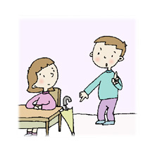
Yes, You can use it. I can lend it to you.
Can I borrow your umbrella? I don’t have one.

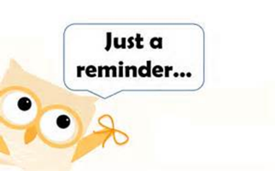
Don’t forget to always return what you borrow from your Friends and Misses.

Source of pics: Woodsville High School, St.Stephen's, Residents', Association, Canterbury, Kent

Family tree
Families are important! We all come from very diverse families and all their members make us a better person every day. Do your remember how to name all the member of your family in English? Let’s remember some:

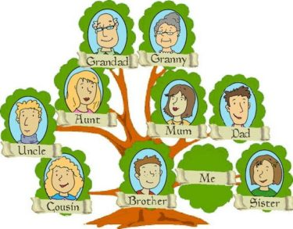
Source of the pic: Diginomica

- Here you can write the name of your family members.
Mother/mum
Father/ dad
Parents
Brother/bro
Sister/ sis
Siblings
Aunt/ auntie
Uncle
Cousin
Grandfather/grandad/grandpa
Grandmother/grandma/granny
Grandparents
Niece
Nephew
Godfather
Godmother
Godparents

Personality and physical traits
- Underline the personality and physical traits you can relate to yourself.
Personality traits | Physical traits
Funny  Friendly  Smart  Serious  Energetic  Outgoing  Nice  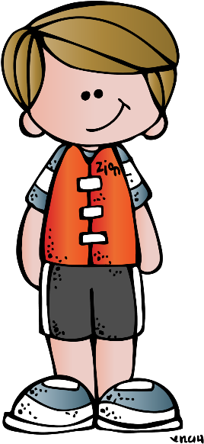  Honest  Shy  Hard-working  Caring  Creative  Generous  Responsible  Stubborn  Respectful  Organized  Selfish  Helpful  Brave  Lazy | Short  Tall  Slim  Thin  Fat  Brown/red/black hair  Blond  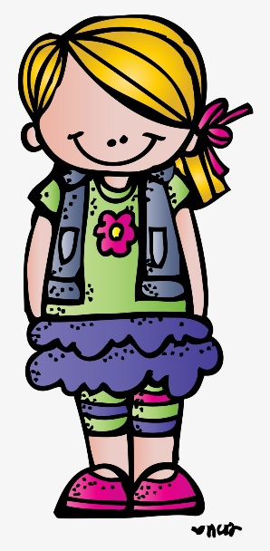  Brunette  Curly hair  Wavy hair  Fair hair  Strong  Weak  Pale/dark skinned  Tanned  Blue/brown/green eyes  Hairy  Furry  Has freckles  Fast (motion)  Slow (motion)  Big/small eyes
Source of pics: PNGkey, pinterest.cl

Thinking about what I learnt
- Circle ○ the best option.
- How many new words did you learn?

A lot A few I know all

- What do you expect of English this year?

- To learn a lot of new vocabulary with games and projects.
- To speak better English in class and oral presentations.
- To read more fun stories in English.
- To express my ideas in English in writing.
- All because I Want to _______________________________________.

- Complete the sentence.
My commitment is to ______________________________________________________________________________________________________ ______________________________________

Source of pic: Whickham Parochial

