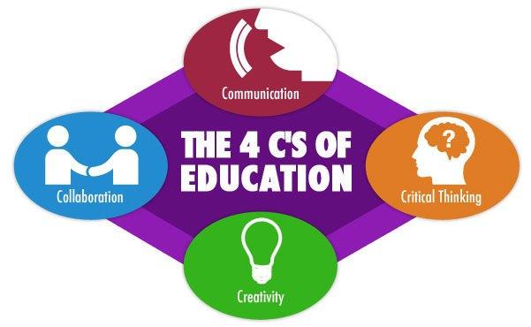
English Department
II Unit / 5th Grade, 2020
P. Bencich & M.A. Vergara

Source: MrAdamPE

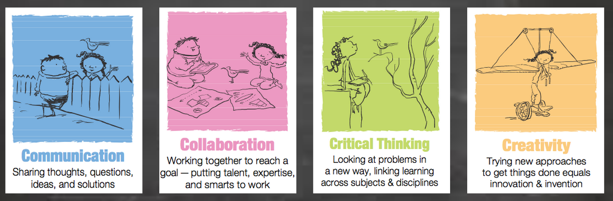

Source: Explorations in Literacy - WordPress.com

