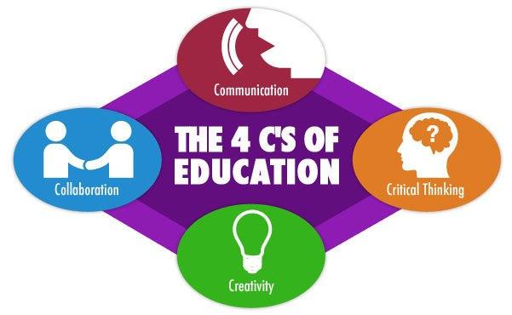
Source: MrAdamPE

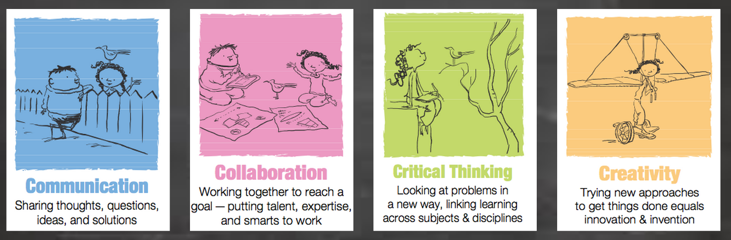

Source: Explorations in Literacy - WordPress.com

